Lab 6

Exercise#1: Design 4-bit, 8-operations (given in Table) Arithmetic Logic Shift Unit as shown in block diagram of figure-2 using initial carry (Cin) as LSB of the control lines of multiplexers. Use control signals and input/output signals in the form of bus.
Boolean Expressions | Logic Diagram
 | 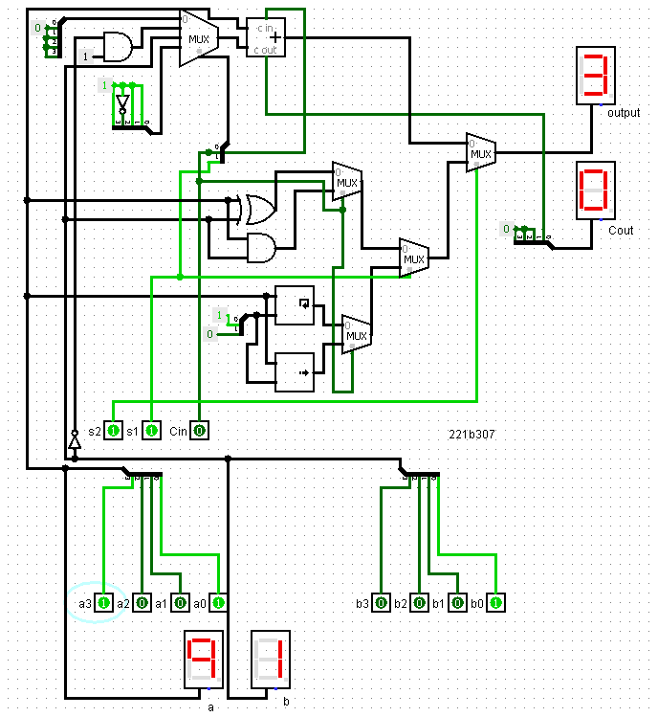
Truth Table or Karnaugh (K) Map

Exercise#2: Design 2-bit array multiplier using in-built block of half adder. Display both the inputs and output result in decimal format using suitable display devices.
Boolean Expressions | Logic Diagram
o0 = a0 b0  o1 = ~a1 a0 b1 + a0 b1 ~b0 + a1 ~a0 b0 + a1 ~b1 b0  o2 = a1 ~a0 b1 + a1 b1 ~b0  o3 = a1 a0 b1 b0 | 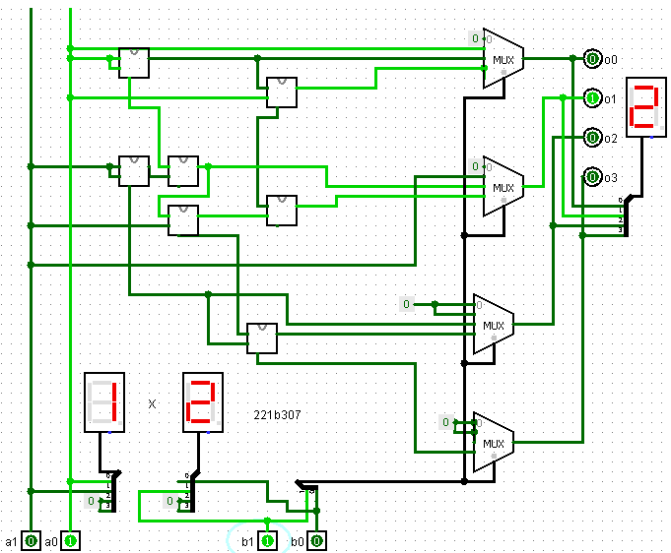
Truth Table or Karnaugh (K) Map
